AKOTHERM AT740
WINDOW SYSTEM

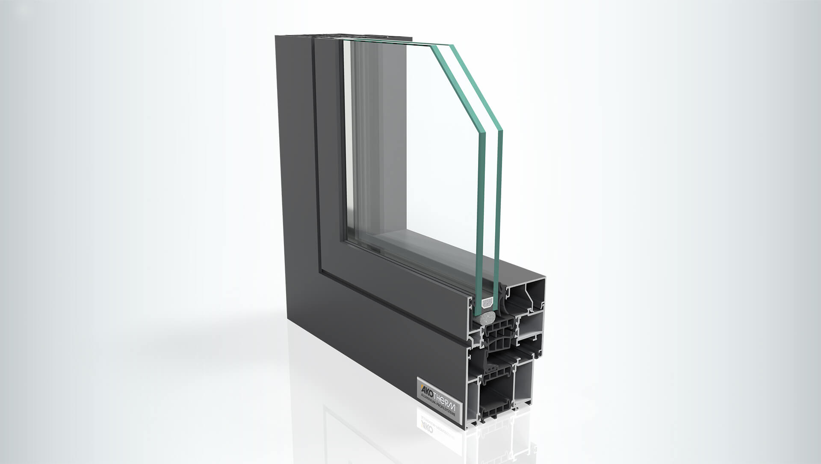

System Description
Economic and demonstrably excellent. The AT 740 window stands for great product quality with all the benefits you can expect from a “state of the art” aluminum window. Burglar resistance up to RC3, sound protection and excellent insulation in compliance with the latest EnEV can be implemented with this system.
Take advantage of the greatest architectural leeway by combining various styles and casement sizes up to 2700 mm tall. Despite eliminating foil-laminated insulation bars, the required U values of the Energy Saving Ordinance (EnEV) can already be reached with double glazing. This is guaranteed in all styles, from hidden vent to design or even open-out window with outward opening casement.
Take advantage of the economic value optimization! The ability to use the same parts of standardized tools and accessories reduces your costs and saves time, since there are no inserting spigots at all. Low priced accessories, quick fabrication times and the greatest possible value optimization ensure cost efficient

